

**“SAHYOG”**

**MINOR PROJECT**

**Submitted in Partial Fulfilment of the Requirements for the Award of the Degree of**

**MASTER OF COMPUTER APPLICATIONS**

**(M.C.A.)**

**BY**

**Praveen kumar**

**(03111604420)**

**MCA – 3 SEMESTER**



**BHARATI VIDYAPEETH’S INSTITUTE OF COMPUTER APPLICATIONS AND MANAGEMENT (BVICAM)**

**(GURU GOBIND SINGH INDRAPRASTHA UNIVERSITY)**

**NEW DELHI**

**Jan, 20****22**

**CANDIDATE’S DECLARATION**

I hereby declare that the work which is being presented in this project work entitled “**SAHYOG**” in partial fulfilment of the requirements for the award of the degree of **Master in Computer Applications at BVICAM** is an authentic record of my own work carried out under the supervision and guidance of **Prof. Sunil Pratap (Associate Professor, BVICAM)**.

I have not submitted the matter embodied in this project work anywhere for the award of any degree or diploma.

**Praveen Kumar(0311604420)**

ii

**ACKNOWLEDGEMENT**

It is my proud privilege to express my profound gratitude to the entire management of BVICAM and teachers of the institute for providing me with the opportunity to avail the excellent facilities and infrastructure. The knowledge and values inculcated have proved to be of immense help at the very start of my career.

I am grateful to **Prof. Sunil pratap**(Project Guide, BVICAM) for his astute guidance, constant encouragement and sincere support for this project work.

I feel pride and privileged in expressing my deep sense of gratitude to all those who have helped me in presenting this assignment. I would be failing in my endeavour if I do not place my acknowledgement**.**

**Praveen Kumar**

**03111604420**

iii

# TABLE OF CONTENTS

**Page No.**

**CHAPTER 1: PROBLEM STATEMENT**

* 1. Description of Project v
  2. Importance & Intended Audience v
  3. Objective and Future Scope vi

CHAPTER 2: Constraints

* 1. Broader Theme vii
  2. Design and Communication vii

CHAPTER 3: System Requirement

* 1. Feature and Functionality viii
  2. User Interface and Communication viii

CHAPTER 4: System Architecture

4.1 Techologies and Languages ix

CHAPTER 5: Feasibility

5.1 Future Iteration x

CHAPTER 6:Group Members Role

6.1 Individual member’s role xi

# CHAPTER 1: PROBLEM STATEMENT

* 1. Description of Project :

“*SAHYOG*” is a webapplication which aims to connect the needy ones to those who are willing to helpsomeone without any demand. The focus of “*SAHYOG*” is to match users based on locations wherethey live or want.

* 1. Importance & Intended Audience :

This website has two types of users one who wants to help someone and the other who has some needs which he/she wants to learn in free . Both have to make an account on the portal and then this website shows them their location and service type. If the services a person wants to take and another person who wants to help someone both have the same location and same service they both will find each other and can directly share their contact number.

All personnel who can give some of his/her time in whole day to bring up someone in their interseted fields and the needy both should register on this website.

Those organisations and NGOs which are running for the orphaned children and those who do not have resouces should also take this opportunity and can also register the children from their organisation .

Not only the sweet home children anyone who has some potential and want to learn something

new according to their choices at any age can register on the ***“ SAHYOG* ”.**

Even anyone who want to give some contribution in money or any service can register over it and found some real people who need help really and can help them .

* 1. Objective and Future Scope :

It has a simple objective -**“To help people find happiness.”**

To provide Social , Educational and Economic Empowerment.

To create various opportunities for individuals. Help someone to use his/her leisure time.

Not only studies one can learn or teach any other field of interest.

To enhace social skills.

*#FUTURE SCOPE:*

Aim to collaborate with other NGO’s working towards similar goals.

To provide a forum for the exchange of ideas on the social ,cultural and educational condition of society. Looking forward to make it live and optimize.

To provide a chatbox so that one can contact through the ***SAHYOG*** portal.

To provide some filters to make searching easier.

# CHAPTER 2: Constraints

* 1. Broader Theme :

Broader theme of the project is to provide Social help for the needy ones those who want to improve their skills.

It also serves as a platform for ones who want to provide some free resources or help to someone.

* 1. Design and Communication :

This project includes both frontend and backend work. Also it includes Database Server which helps to manage data and records so that we can access it easily.

It also serves a good communication between the two ends of project .Also serves a good communication between the service provider and service seeker.

*I* will start the project from scratch.

# CHAPTER 3: System Requirement

* 1. Feature and Functionality :

Network Building: as it connects people to grow mutually.

Privacy : No one can see personal details of other without permission.

Easy connectivity

Give exposure to users.

* 1. User Interface and Communication :

User Interface of SAHYOG is quite familiar to its users. One can easily find Registration form / Login form on first visit on Home page.

On Home Page there will be logo and description about the website.From there one can go to Registration tab and fill the form.

The Registration form is a simple form which asks the user about its personal details alongwith field of interest.

After registration while one can login with their ID and password they will find search results according to their Registration form details.

# CHAPTER 4: System Architecture

4.1 Techologies and Languages :

HTML5 : is used to build structure the content of website.

CSS3 : is used to style the HTML documents. JavaScript : is used to make pages dynamic.

React : a javascript library is used to make SPA. NODE.JS : is used to work with database and server connectivity.

Mongo DB : is used as database.

 Dependencies and modules which we used : axios

react react-dom

react-router cors express

jsonwebtoken mongoose

# CHAPTER 5: Feasibility

5.1 Future Iteration :

Looking forward to make this website live. To provide a chatbox which will help users to communicate easily.

Adding on a complaint & suggestion form.

Aim to collaborate with NGO’s and organisation so that every needy child can register over it.

To provide filter for a better searching.

**Some Code Snippets :**

**code of backend :**

>>code of server file which connects express and mongo db.

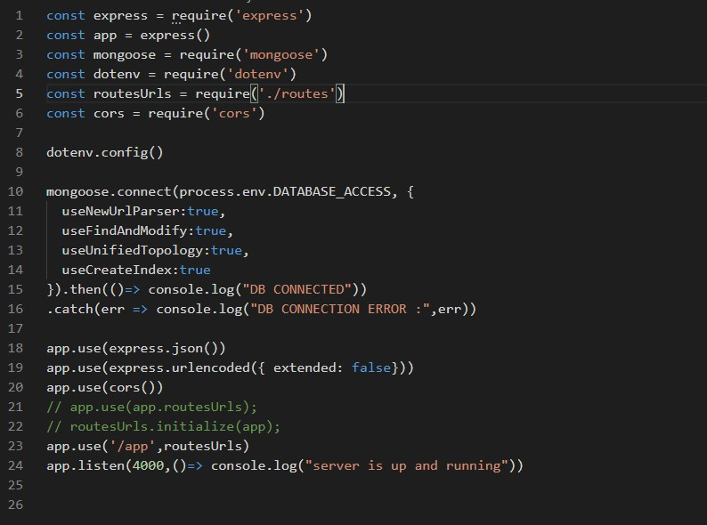

>>code of post for registration form which post data to the database.

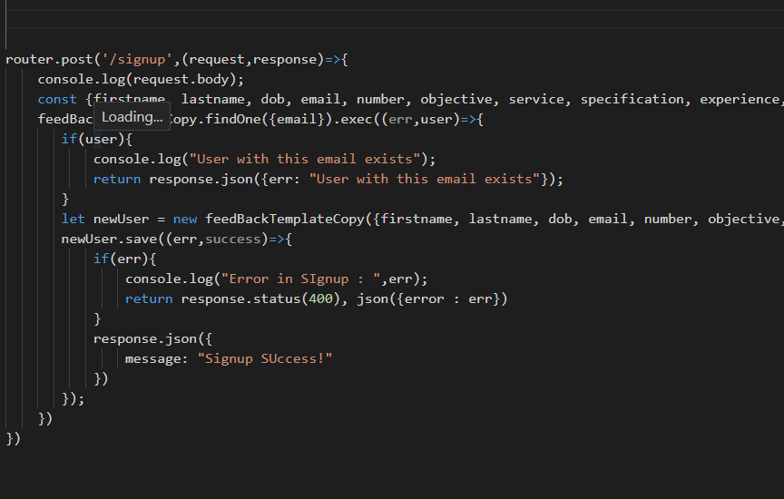

>>code of post for info form which is visible after succesful login.

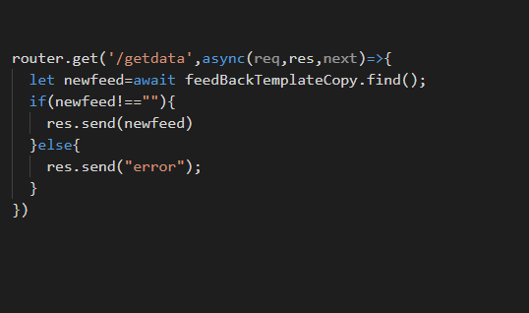

>>code of post for info form which is visible after succesful login.

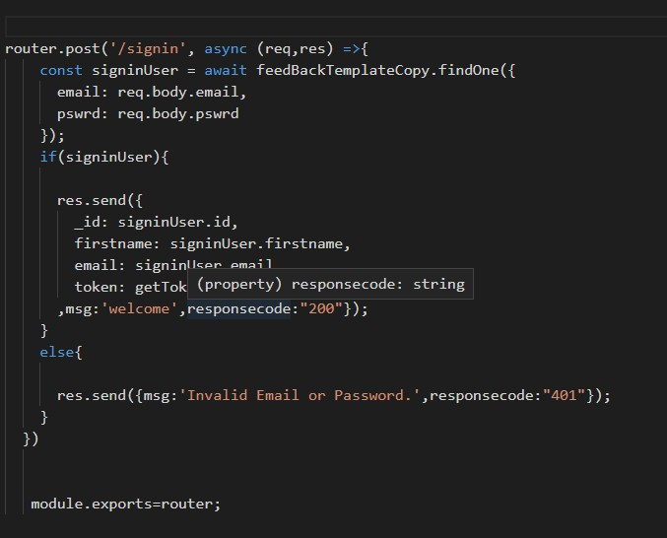

>>code of schema and model for database

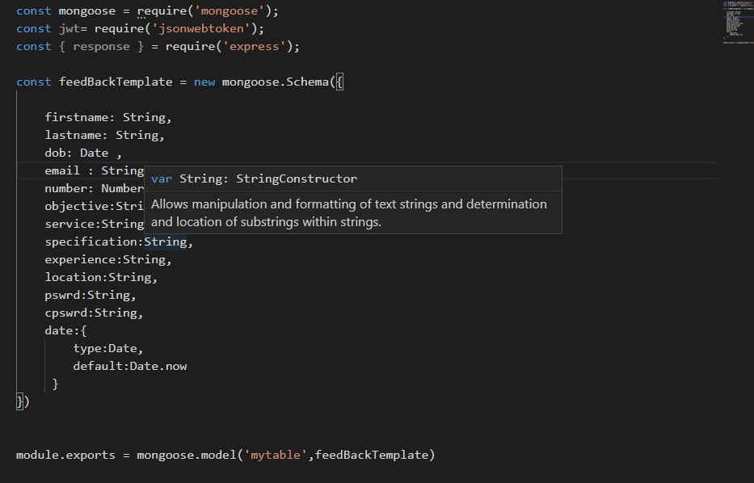

**code of frontend:**

>>file for axios coding in registration form.

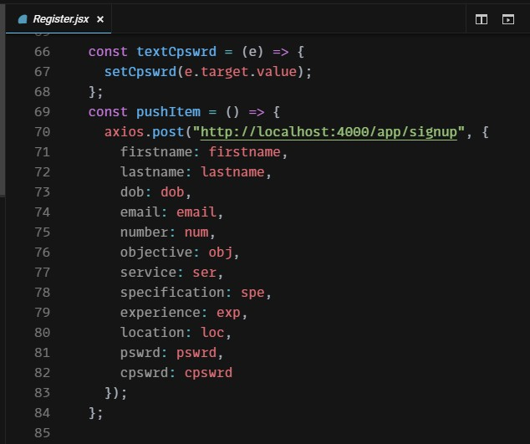

>>File for axios for login functionality.

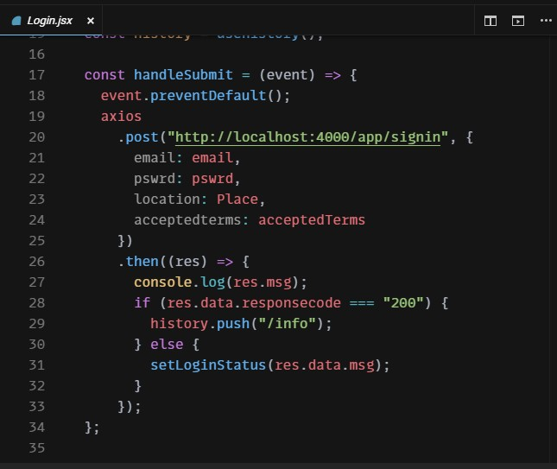

>>File for axios for info page.

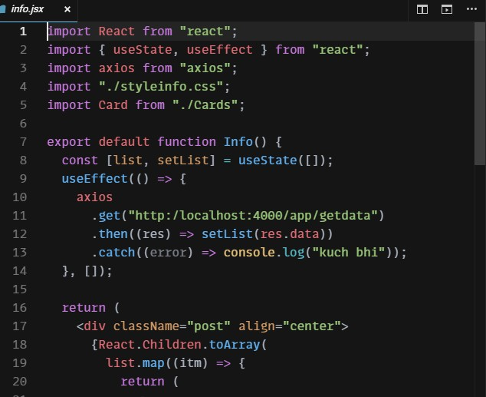

>>List of dependencies used in project.

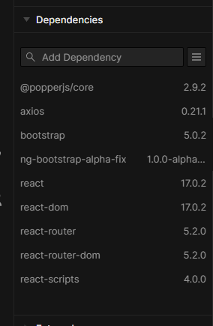

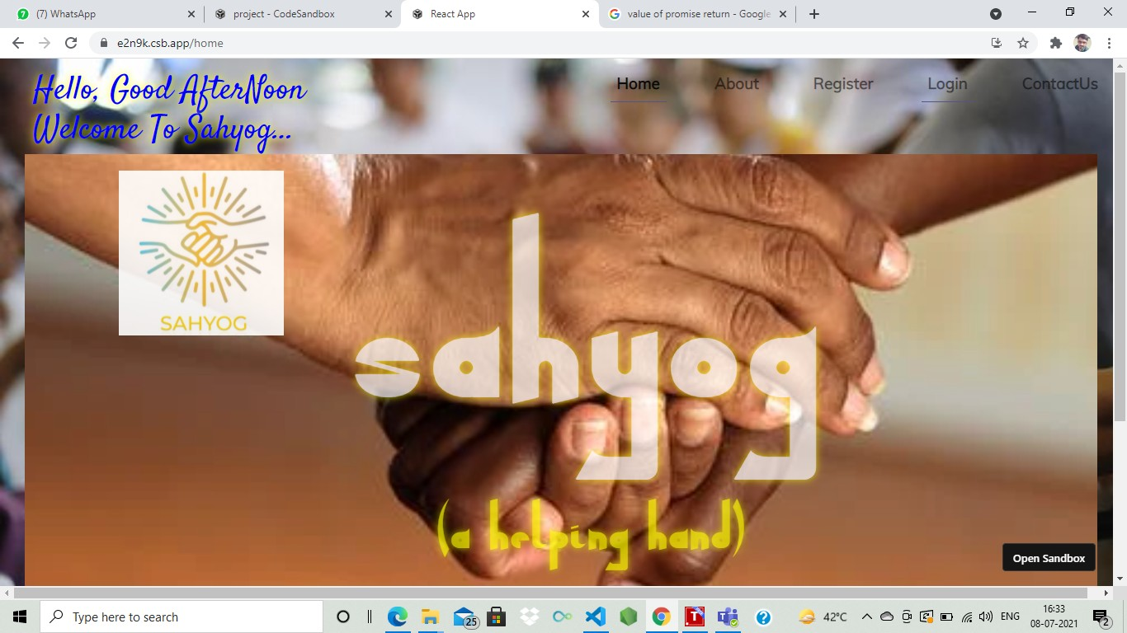**Some Snippets of interface : Home Page :**

**About Page :**

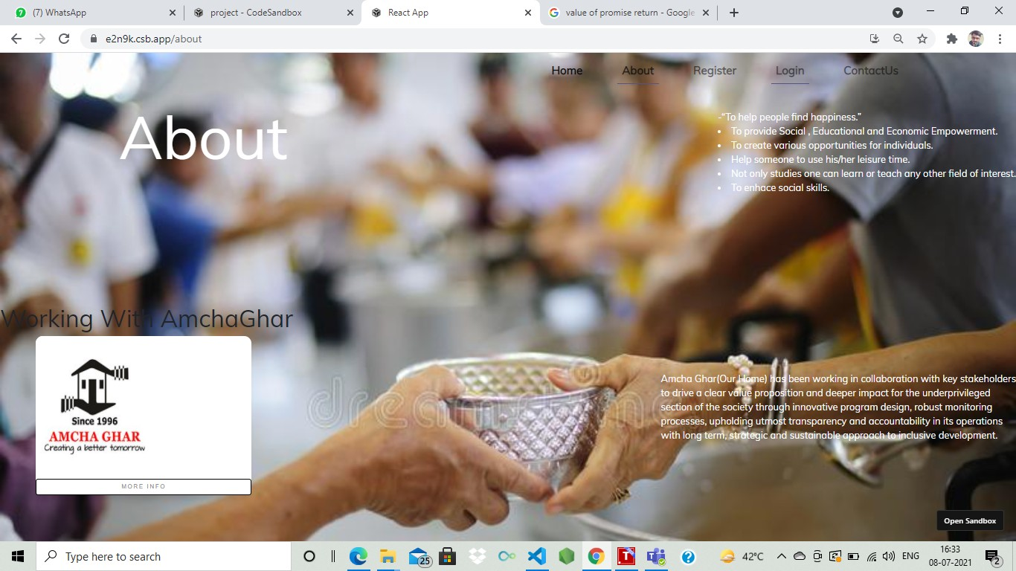

**Registration Page :**

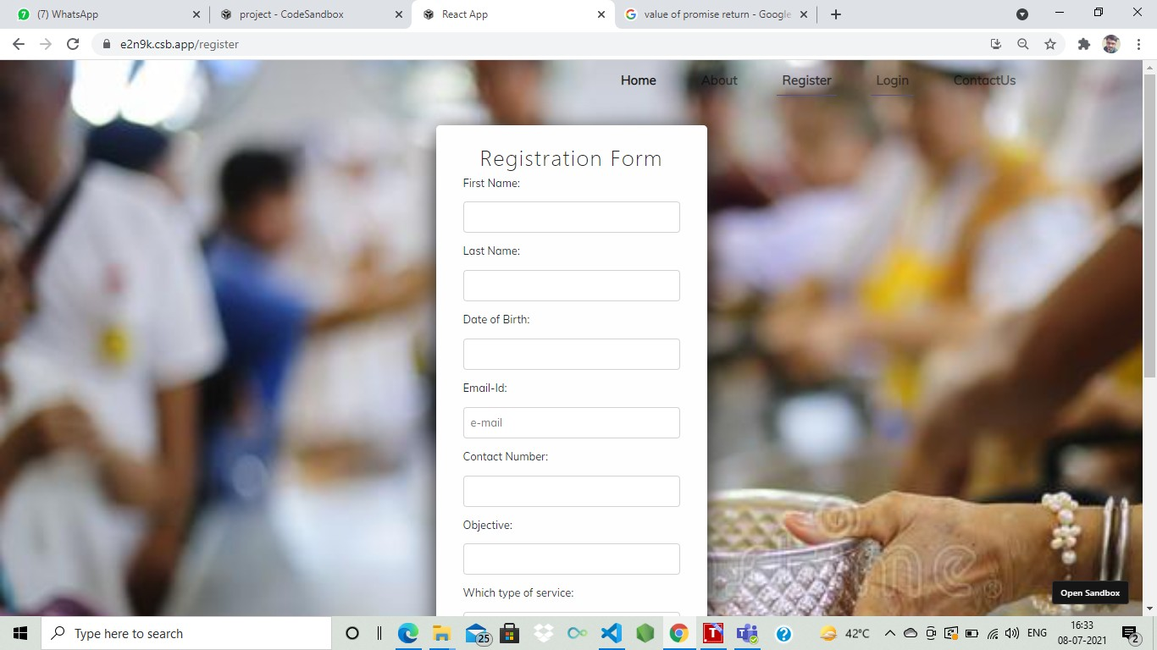

**Login Page :**

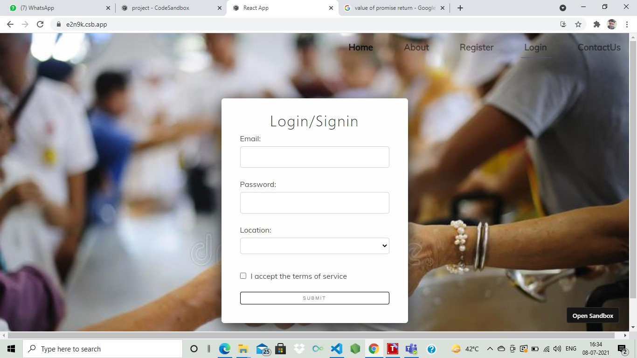

**Info Page :**

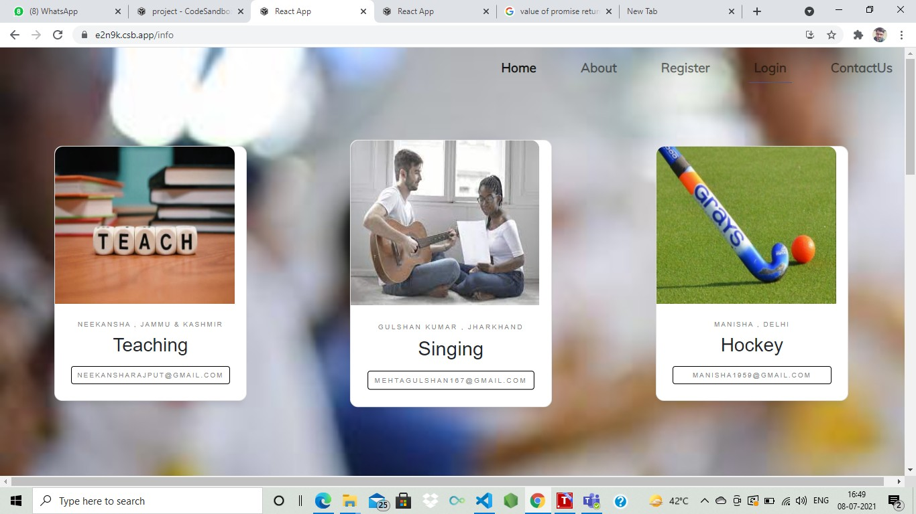

Made by,

Praveen Kumar

(03111604420)

THANK YOU !!!

(Approval/Rejection of proposal by Subject Coordinator: Yes/No.): ---------------